**Name: Umamah Hussain**

**Roll Number: 21L-1858**

**Section: BSCS-5C**

**Task 3:**

1. **Retrieve a list of all appointments, including the patient's and doctor's names.**

select A.PatientID, P.FirstName, P.LastName,A.DoctorID, D.FirstName, D.LastName, A.AppointmentID, A.AppointmentDate, A.AppointmentTime

from Patients P, Doctors D, Appointments A

where A.PatientID=P.PatientID and A.DoctorID=D.DoctorID

or

Select A.AppointmentID, A.AppointmentDate, A.AppointmentTime, P.PatientID, P.FirstName AS PatientFirstName, P.LastName AS PatientLastName, D.DoctorID, D.FirstName AS DoctorFirstName, D.LastName AS DoctorLastName

From Appointments A

JOIN Patients P ON A.PatientID = P.PatientID

JOIN Doctors D ON A.DoctorID = D.DoctorID;

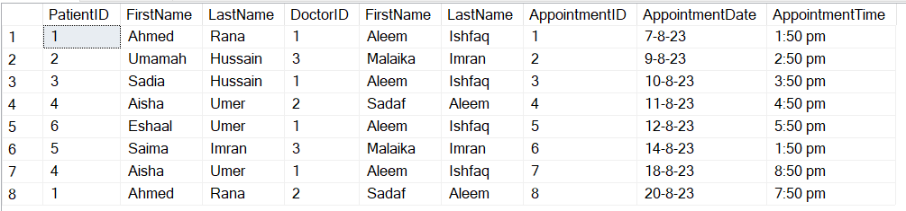

1. **Retrieve the medical records of patients with their names and the diagnosing doctor's name**

select M.PatientID, P.FirstName, P.LastName, M.DoctorID, D.FirstName, D.LastName, M.Diagnosis, M.Treatment, M.RecordDate

from Patients P, Doctors D, MedicalRecords M

where M.PatientID=P.PatientID and M.DoctorID=D.DoctorID

or

select M.PatientID, P.FirstName, P.LastName, M.DoctorID, D.FirstName, D.LastName, M.Diagnosis, M.Treatment, M.RecordDate

from MedicalRecords M

join Patients P on M.PatientID=P.PatientID

join Doctors D on M.DoctorID=D.DoctorID

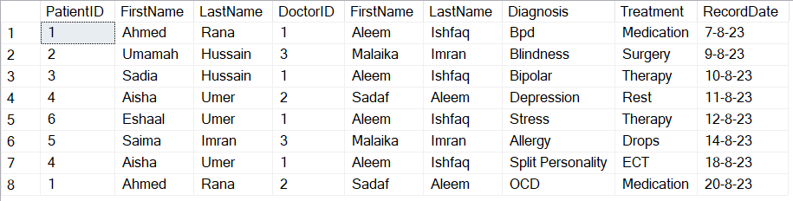

1. **Find patients who have not made any appointments.**

Patients List:

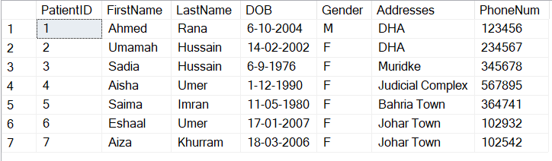

Appointments List:

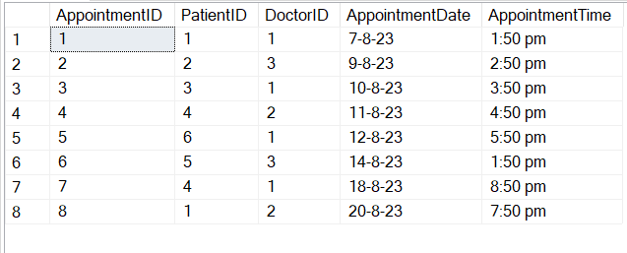

select P.PatientID

from Patients P

except

select A.PatientID

from Appointments A



Or

select P.PatientID, P.FirstName, P.LastName

from Patients P

Left join

Appointments A on A.PatientID=P.PatientID where A.AppointmentID is null;

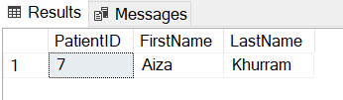

1. **Retrieve a list of patients who have appointments scheduled for a specific date, including the appointment details and the doctor's name. [2023-09-06]**

select A.PatientID, P.FirstName, P.LastName,A.DoctorID, D.FirstName, D.LastName, A.AppointmentID, A.AppointmentDate, A.AppointmentTime

from Patients P, Doctors D, Appointments A

where A.PatientID=P.PatientID and A.DoctorID=D.DoctorID and A.AppointmentDate='7-8-23'

or

select A.PatientID, P.FirstName, P.LastName,A.DoctorID, D.FirstName, D.LastName, A.AppointmentID, A.AppointmentDate, A.AppointmentTime

from Patients P

join

Appointments A on A.PatientID=P.PatientID

join Doctors D on A.DoctorID=D.DoctorID

where A.AppointmentDate='7-8-23'



1. **Retrieve a list of patients who have appointments with doctors having the same specialization as their diagnosis**

select distinct P.PatientID, P.FirstName, P.LastName, D.DoctorID,D.FirstName,D.LastName,M.Diagnosis, D.Specialization

from Patients P, Appointments A, MedicalRecords M, Doctors D

where M.Diagnosis=D.Specialization and M.PatientID=P.PatientID

or

select P.PatientID, P.FirstName, P.LastName

from Patients P

join Appointments A on A.PatientID=P.PatientID

join MedicalRecords M on M.PatientID=A.PatientID

join Doctors D ON M.Diagnosis = D.Specialization;

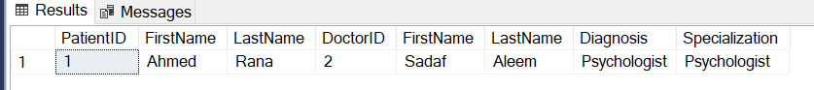

1. **List all distinct doctors and patients (by name) who have either made appointments or have medical records in the database**

select distinct P.PatientID, P.FirstName, P.LastName, D.DoctorID,D.FirstName,D.LastName

from Patients P, Appointments A, MedicalRecords M, Doctors D

where (M.PatientID=P.PatientID and A.PatientID=P.PatientID) and (M.DoctorID=D.DoctorID and A.DoctorID=D.DoctorID);

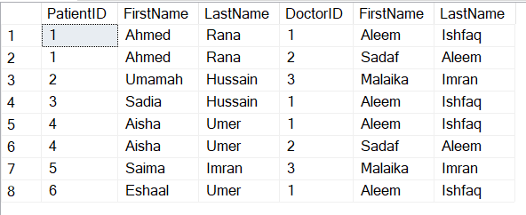

1. **Find doctors who have the same specialization as another doctor and list their names along with the common specialization.**

Select D1.FirstName, D1.LastName, D1.Specialization

from Doctors D1

join Doctors D2 on D1.Specialization = D2.Specialization and D1.DoctorID <> D2.DoctorID;

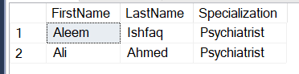

1. **List all patients who have medical records and have been diagnosed with "Hypertension," ordered alphabetically by their last names**

select distinct P.FirstName, P.LastName, M.Diagnosis

from Patients P, MedicalRecords M

where M.Diagnosis='Hypertension' and M.PatientID=P.PatientID

order by P.LastName asc

